Greetings from the Storer College National Alumni Association!

13 December 2022
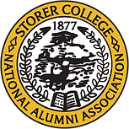
As we close this calendar year, we look back and thank God for the ability to “Preserve, Educate and Give” on behalf of Storer’s legacy.
What a year it has been! Since the pandemic, the SCNAA has connected with many alumni, friends, and family of Storer College. The projects we focused on this past year helped us support our communities and preserve the legacy of the former normal school that later became known as Storer College.
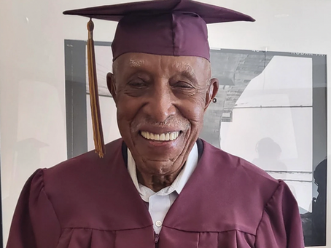
The SCNAA proudly helped arrange for one of Storer’s oldest living attendees, Merrill Pittman Cooper, to receive an Honorary High School Diploma at the age of 101 years young!
We invite you to visit our website (storercollegealumni.org) to read his Washington Post article, view the Good Morning America media coverage, and enjoy other memorabilia of our efforts to cherish memories and keep Storer’s legacy alive.
The SCNAA awarded a book scholarship to a student attending Hagerstown Community College and nominated another student to receive the Storer College Endowment Fund Scholarship given at Virginia Union University. We also provided monetary support to an elementary school teacher for “back to school” supplies and we gave a cash donation to a local scholarship program dedicated to helping West Virginia high school students after graduation. In addition, the SCNAA furnished gift cards to a centenarian Storer graduate in need of financial assistance, and donated money to buy food and school supplies for local elementary school students.
The SCNAA participated in the 28th Annual African American Cultural & Heritage Festival, and donated school supplies to elementary school students in attendance. An overview of Storer College was presented by the SCNAA President to Harpers Ferry Middle School students, and SCNAA members served as tour guides for a walking field trip to the former Storer campus.
However, the “Crown Jewel” of our 2022 accomplishments was the 155th Anniversary celebration of Storer College. Several middle and high school students participated in the program, which featured distinguished guest speakers, a book signing, and the recognition of Storer College alumni who are still living, and those who have passed away. An article summarizing the event appeared in The Journal, one of our local newspapers (www.journal-news.net).
In the coming year, the SCNAA will continue building on our vision to preserve Storer’s rich history, and to encourage learning through scholarship, education, tours, and events. We are fully committed to growing the legacy and introducing Storer College to our youth, our communities, and the world. The SCNAA relies on membership dues and donations to achieve these goals.
Are you able to help us “Preserve the Legacy and Cherish the Memories” of Storer College?
Become a member of the Storer College National Alumni Association by paying an annual membership due of $50.00, OR, make a tax-deductible donation in an amount of your choice. Please make checks payable to SCNAA and indicate (on the memo line) if you’re paying an annual membership due or giving a donation. Checks should be mailed to SCNAA, P.O. Box 867, Harpers Ferry WV 25425-0867.
Your support is needed and greatly appreciated. Thanks for all that you have done, and will do, to keep the Storer College story alive! Take care, be blessed, and enjoy the holidays!

With Humility and Gratitude,
James Green, Jr.
SCNAA President

Here are some ways you can donate:
By Mail  P.O. Box 867  Harpers Ferry, WV  25425-0867 | Online  Visit storercollegealumni.org  Click on Donate | Over the Phone  It’s easy to donate offline too.  (703) 989-7354

